# Financial Aid Appeal for the 2021-2022 year

During the year 2020, the Argentinian Government imposed a new 35% tax over the previous 30% tax over the purchase of foreign currencies for saving and payment purposes.

This document explains the impact of the new tax on the cost of attendance to Rice and provides supporting documentation detailing the specifics of the new law.

## Impact

## Supporting Documentation

### New 35% tax

Link to the decree: <https://www.boletinoficial.gob.ar/detalleAviso/primera/235038/20200916>

Screenshot of the section detailing the tax amount to be perceived:

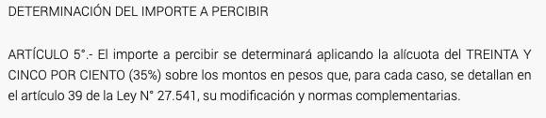

Translation of the aforementioned section:

DETERMINATION OF THE AMOUNT TO BE PERCEIVED

Section 5 - The amount to be perceived will be determined by applying the rate of THIRTY-FIVE PERCENT (35%) on the amounts in pesos that, for each case, are detailed in section 39 of Law No. 27,541, its modification and complementary regulations.

<http://servicios.infoleg.gob.ar/infolegInternet/anexos/330000-334999/333564/norma.htm>

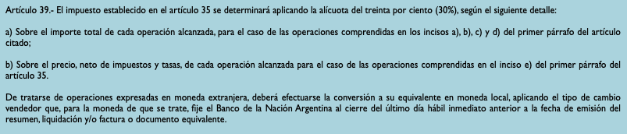

Section 39 - The tax established in section 35 will be determined by applying the rate of thirty percent (30%), according to the following detail.

1. On the total amount of each transaction reached, in the case of transactions included in items a), b), c) and d) of the first paragraph of the aforementioned section;
2. On the price, net of taxes and fees, of each operation reached in the case of operations included in subparagraph e) of the first paragraph of section 35.

In the case of operations expressed in foreign currency, the conversion must be made to its equivalent in local currency, applying the selling exchange rate that, for the currency in question, is set by the Banco de la Nación Argentina at the close of the last immediate business day prior to the date of issuance of the summary, settlement and/or invoice or equivalent document.

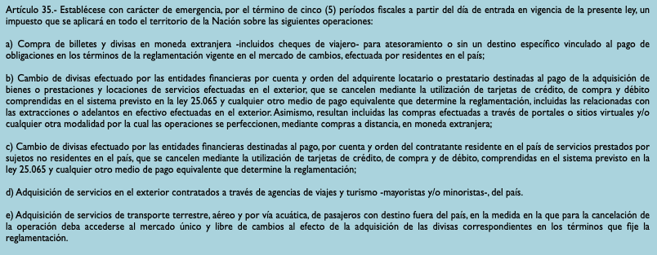

Section 35 - It should be established on an emergency basis, for the term of five (5) fiscal periods from the date of entry into force of this law, a tax that will be applied throughout the territory of the Nation on the following operations:

1. Purchase of banknotes and currencies in foreign currency -including traveler's checks- for storage or without a specific destination linked to the payment of obligations in the terms of the regulations in force in the exchange market, carried out by residents of the country;
2. Currency exchange carried out by financial entities on behalf and order of the tenant or borrower purchaser for the payment of the acquisition of goods or services and leases of services carried out abroad, which are paid through the use of credit, purchase and debit cards included in the system provided for in law 25,065 and any other equivalent means of payment determined by the regulations, including those related to withdrawals or cash advances made abroad. Likewise, purchases made through portals or virtual sites and / or any other method by which operations are perfected, through distance purchases, in foreign currency are included;
3. Currency exchange carried out by financial entities for the payment, on behalf and order of the resident contractor in the country of services provided by non-resident subjects in the country, which are paid through the use of credit, purchase and credit cards, included in the system provided for in law 25,065 and any other equivalent means of payment determined by regulation;
4. Acquisition of services abroad contracted through travel and tourism agencies - wholesalers and / or retailers - in the country.
5. Acquisition of land, air and water transport services for passengers with destinations outside the country, to the extent that for the payment of the operation the single and free foreign exchange market must be accessed for the purpose of acquiring the corresponding foreign currency in the terms established by the regulations.